G C

RCarson10

Abstract

This product implements three methods for solving differential equations by written and coded demonstrations

Project 3 – Green's Function and ODE with IVP

By Gaj Carson

# **Abstract**

In engineering and signal processing, the delta function (also know as the impulse symbol) may be regarded through it’s Laplace Transform coming from the boundary values of complex analytic functions of a complex variable.

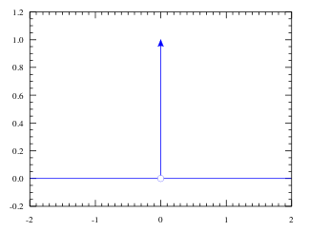

The Heaviside step function H(x), θ(x), or n(x) unit step function.

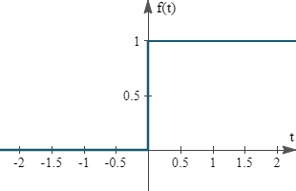

The derivative of a step function is given by $\frac{d}{dx}*H\left(x\right)= δ(x)$.

$$\int_{-∞}^{∞}{f\left(x\right)δ\left(x-a\right)dx=f\left(a\right)}$$

$$\int_{a-ϵ}^{a+ϵ}{f\left(x\right)δ\left(x-a\right)dx=f\left(a\right) ϵ>0}$$

$$\frac{d^{2}y}{dt^{2}}+p\left(t\right)*\frac{dy}{dt}+q\left(t\right)y = r\left(t\right), y(0) = y’(0) = 0$$

The P(t) and q(t) functions of t and this a second order ODE. And, we use $y(0) = y’(0) = 0$ to solve the ODE with the function $G\left(t,s\right)= \left\{\begin{aligned}0, t<s \\ g\left(t,s\right), t>s\end{aligned}\right.$

Where r(t) = 0, g(s,s) = 0, and the derivative evaluated at t = s, $\frac{d}{dt}*g(t,s)\left|\begin{aligned}=1 \\ t=s\end{aligned}\right.$

$Yp=\int_{0}^{t}{g\left(t,s\right)*r(s)ds}$

**By Hand Calculations for Equation 1**

Where $y^{''}+2y^{'}=2x-2, y\left(0\right)=y{\left(0\right)}^{'}=0,{ λ}_{1}=0 and { λ}_{2}=-2 and y\left(h\right)=c_{1}+c_{2}e^{-2x}$, starting with the method of Undetermined Coefficients, then Variation of Parameters, and lastly the Green’s function.

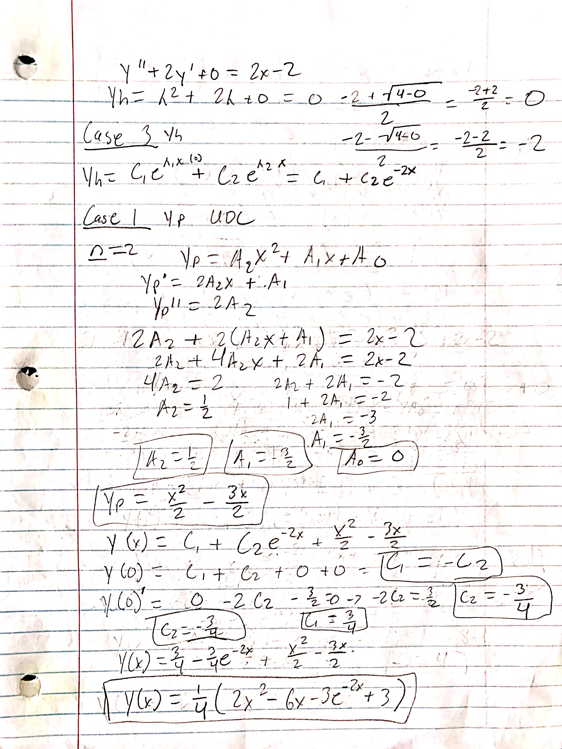

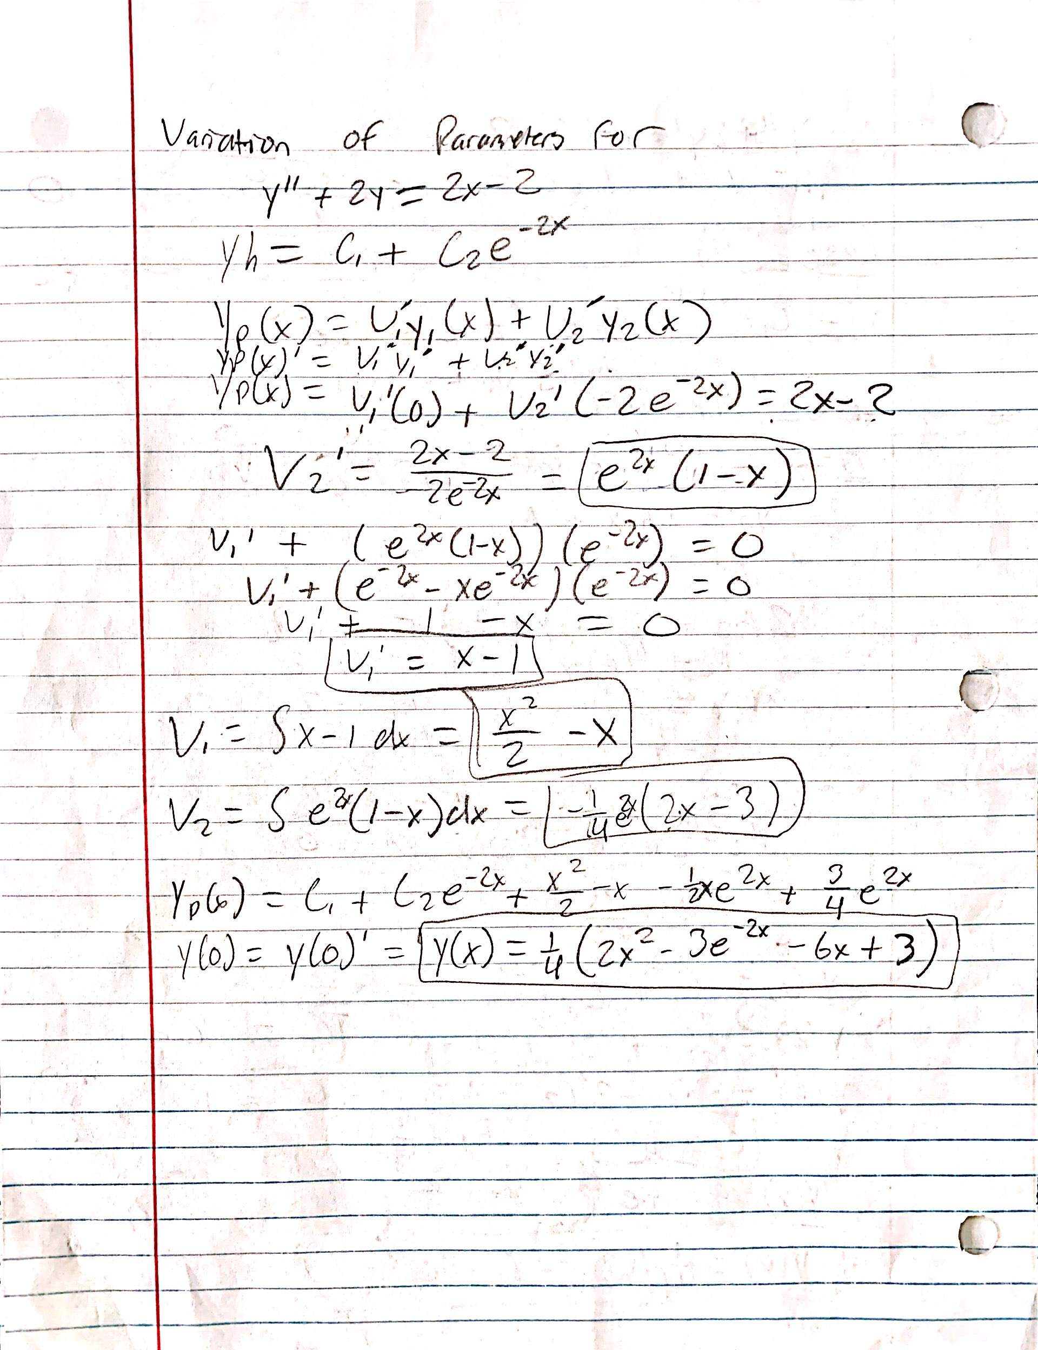



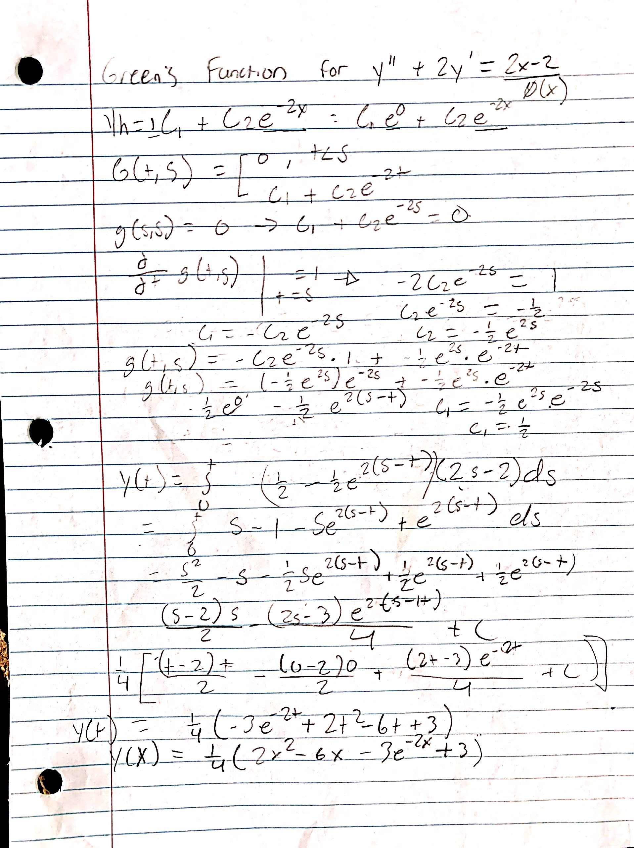

All of the methods ended with the same result, $y\left(x\right)=1/4(2x^{2}-6x-3e^{-2x}+3)$.

The next equation starts with the values of $y^{''}+y=4, y\left(0\right)=y{\left(0\right)}^{'}=0, λ_{1}= -λ_{2} and y\left(h\right)=c_{1}\cos\left(x\right)+c_{2}\sin\left(x\right)$, the by hand calculations are shown by the pictures below in the same format as the question above.

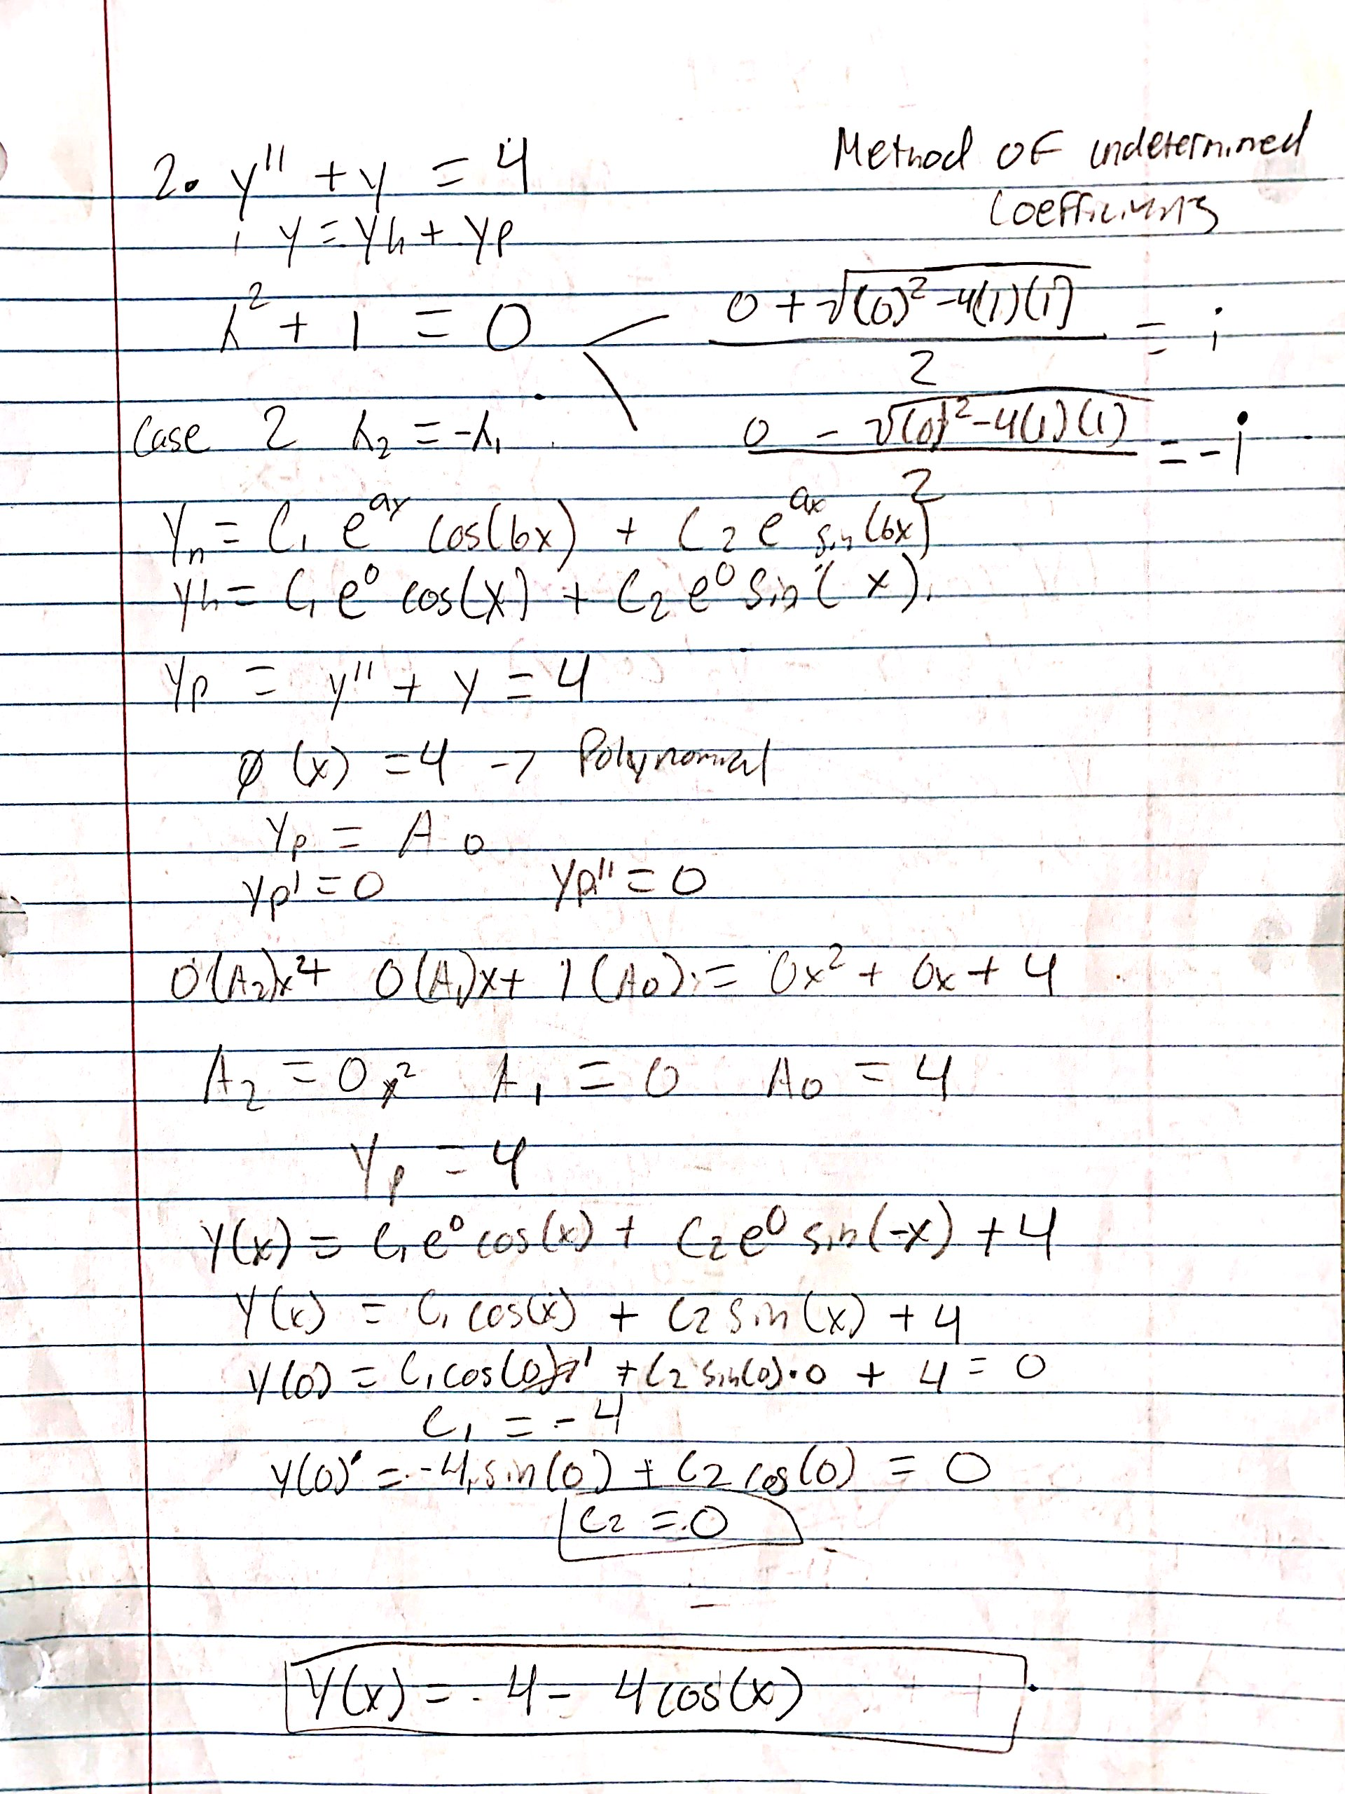

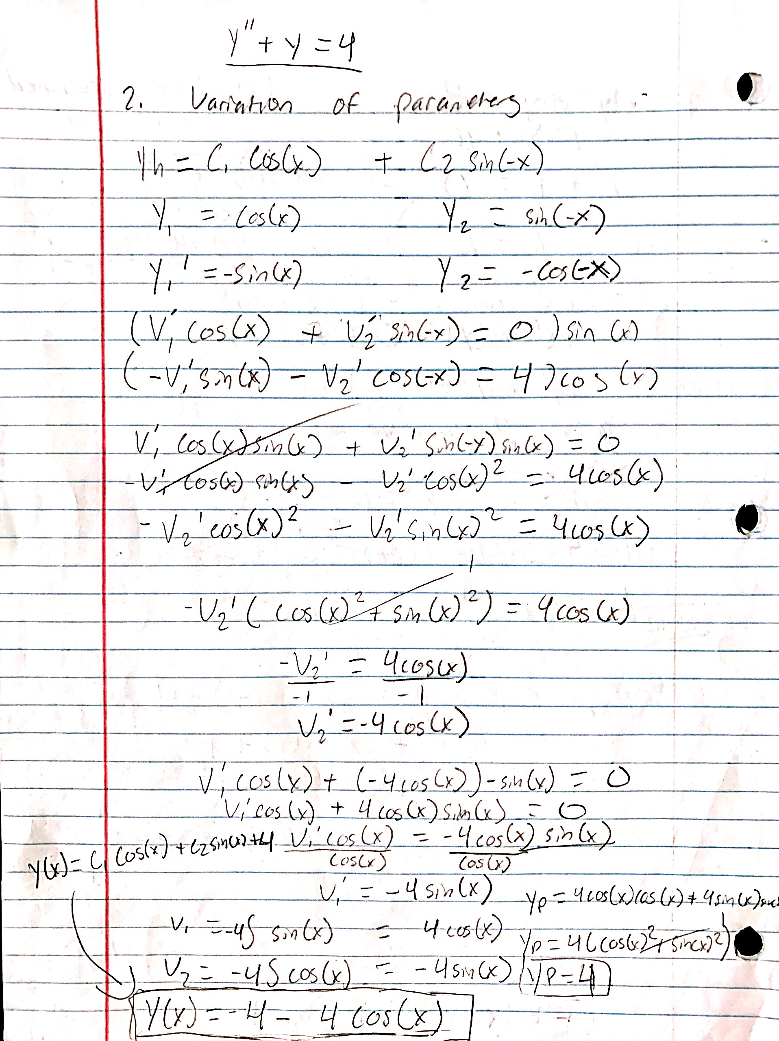

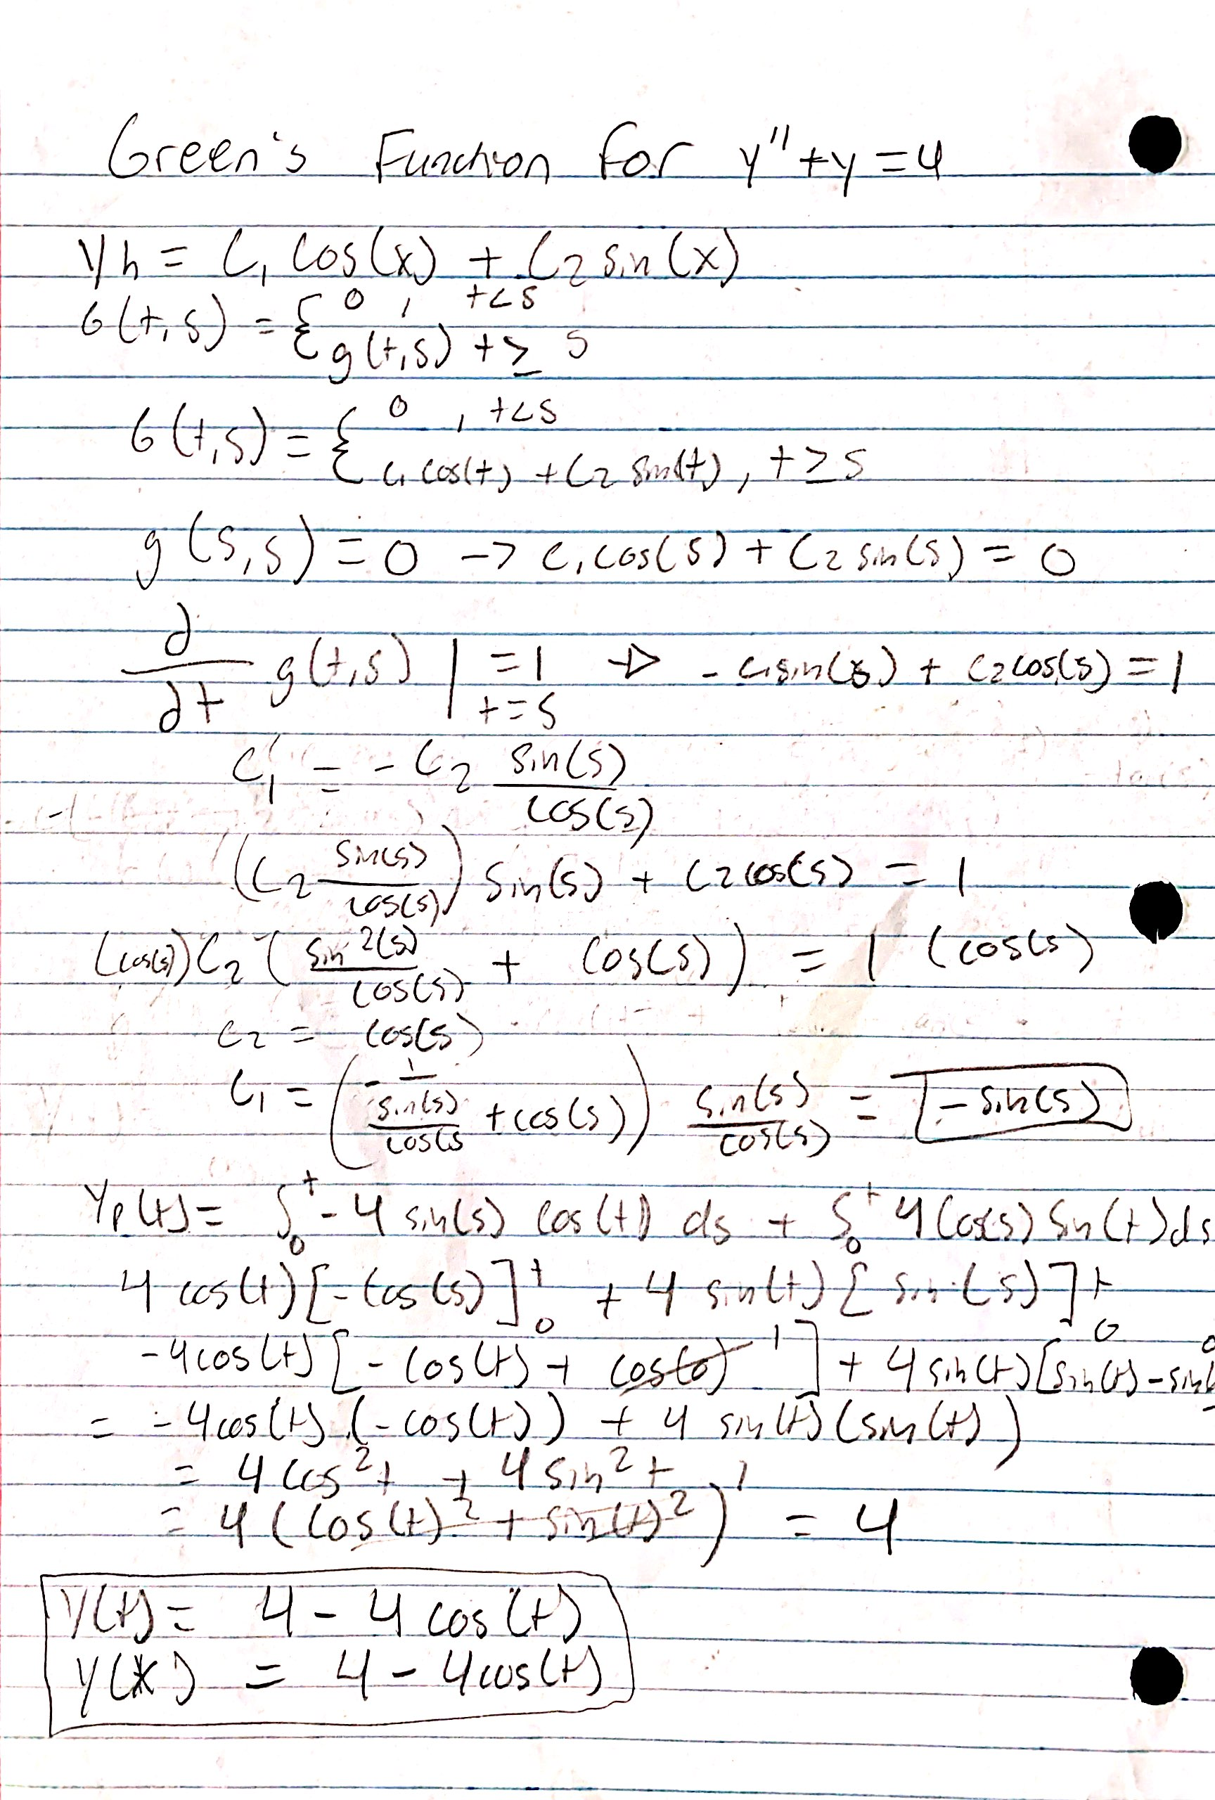

The results from the second equation were $y\left(x\right)=4-4cos⁡(x)$ with all the methods above producing matching outputs.

Below is the flowchart which outlines the process of solving the ODE’s and generalizes what the code is doing.

### Flowchart

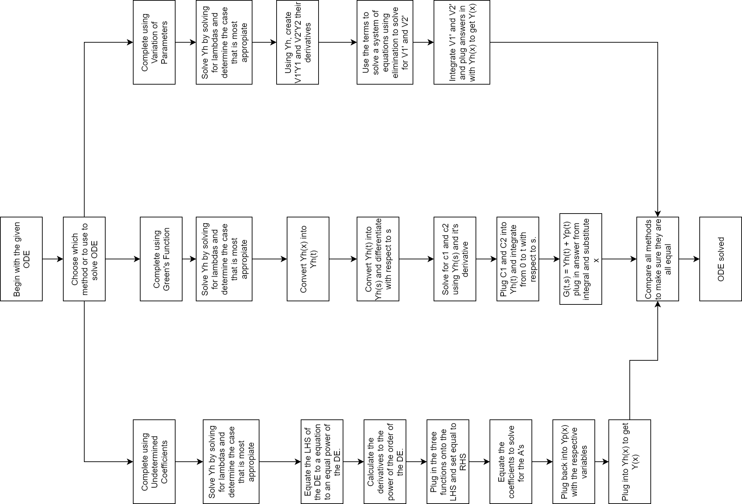

### Code Output

## Lastly, these are the code outputs for all the graphs followed by screenshots of the code. Starting with equation one and the ending with equation 2.

## 

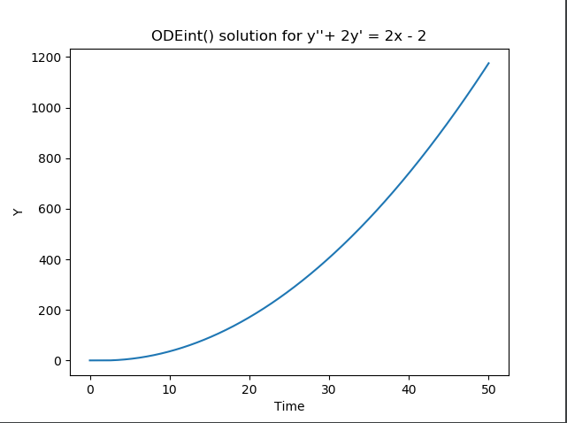

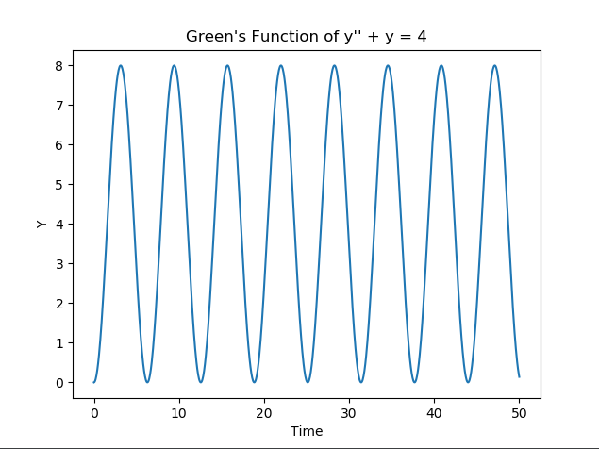

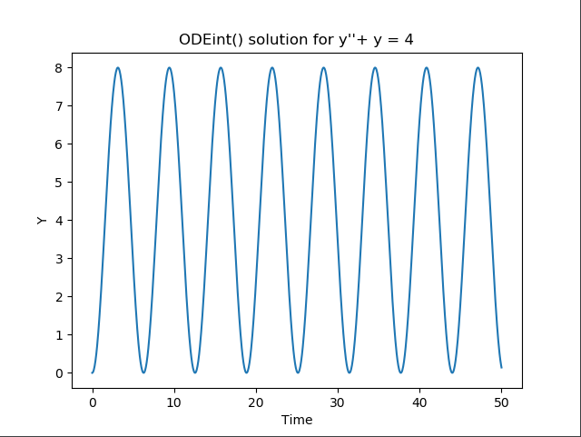

## 

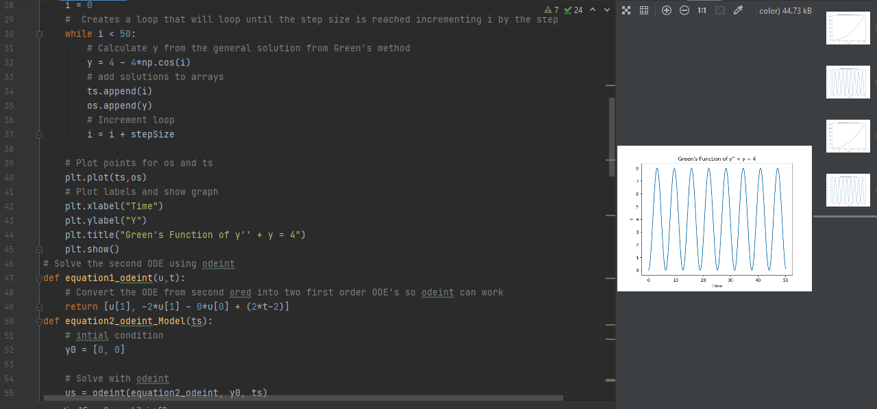

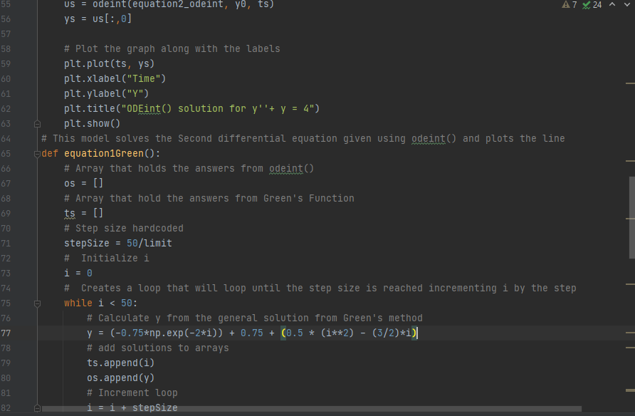

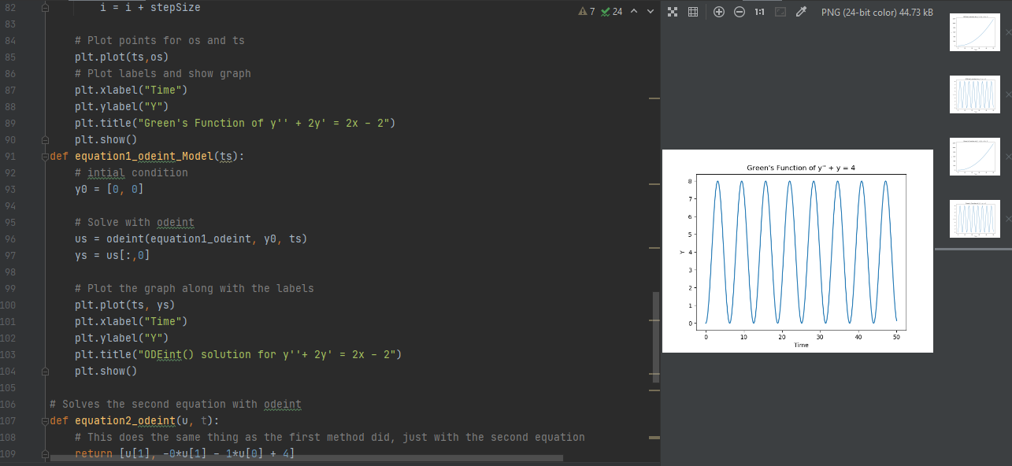

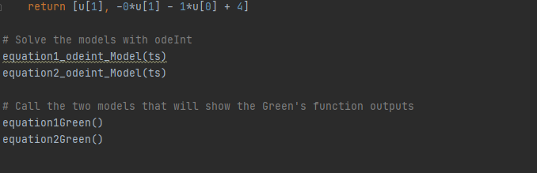

## References

1. <https://en.wikipedia.org/wiki/Dirac_delta_function>
2. https://www.intmath.com/laplace-transformation/1a-unit-step-functions-definition.php